Unit 2
The 8th level
COMPECENCE:
Communicative Competence – Producing oral messages (Speaking);
Methodological Competence – Building skills of self-development, self-control, and self-evaluation;
Interdisciplinary Competence – Knowing linguistic and cultural relationships / connections.
UNITS OF COMPECENCE:
Producing a simple speech withappropriatefluency, stress, intonation.
Using an appropriate vocabulary, including the old and the new words.
Using te computer to create a video or a Power Point Presentation.
OBJECTIVES:
- to create a shortvideo or a Power Point Presentationusingstatementsandimages;
- topresenttheworkorallywithappropriatefluency, stress, intonation.

Evaluation tool:Video or a Power Point Presentation
Method: Individual project
Topic:“My future job”

Task: Create a video or a Power Point Presentation to speak about your future job, using the following the plan:
- What would you like to be?Why?
- What does your future job requires to do?
- Where would you like to work?
- What are some most important features and abilities necessary for this profession?
- What 3 characteristics do you possess or what 3 abilities do you have that would help you in your future job?
- What are 3 steps you should do to achieve your goal?

Evaluationcriteria:
- Content (12points);
- Design (25points);
- Oral presentation(12points).

Extra points: 1p. – for originality

Total score: 50points

Criteria | Descriptors
Score | 4 points | 3points | 2points | 1 point
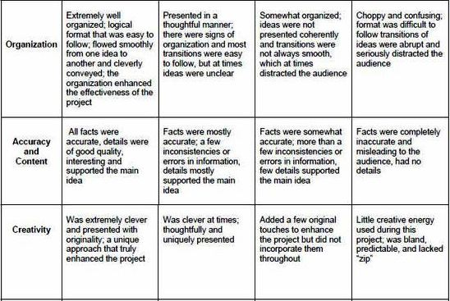

Criteria | Descriptors
Score | 5points | 4 points | 3 points | 2 points | 1 point
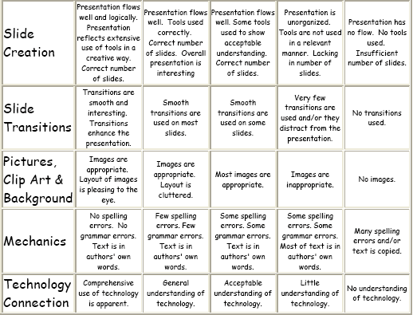

Criteria | Descriptors
Score | 4 points | 3 points | 2 points | 1 point
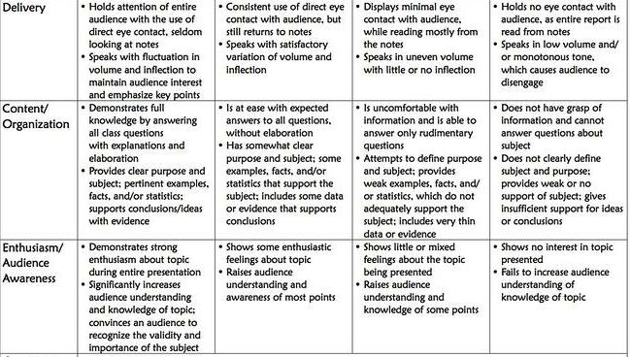

49 - 50p. – « 10» 15 –23p. - « 5»
46 – 48p. - « 9» 9 - 14p. - « 4»
39 – 45p. - « 8» 5 - 8p. - « 3»
34 – 38p. - « 7» 3 - 4p. - « 2»
24 – 33p. - « 6» 1 - 2p. - « 1»

