Unit 3
The 7th level
COMPECENCE:
Communicative Competence – Producing oral messages (Speaking);
Methodological Competence – Building skills of self-development, self-control, and self-evaluation;
Interdisciplinary Competence – Knowing linguistic and cultural relationships / connections.
Digital competence.

UNITS OF COMPECENCES:
Producing a simple speech withappropriatefluency, stress, intonation.
Using an appropriate vocabulary, including the old and the new words.
Using te computer to create an online poster designed with texts, images, links and videos.

OBJECTIVES:
- to create a short video using statements and images on the given topic;
- to create an online poster designed with texts, images, links andvideos;
- to present the work orally, speaking with appropriate fluency, stress, intonation.

Evaluationtool: Online poster or wallpaper
Method: Individual project
Topic:“My ideal house”

Task: Create a video or a an online poster designed with texts, images, links and videos, using the following online tools: Glogster, Padlet, Pinterest, Listly or ThingLink and the teacher’s model:https://padlet.com/mursu_avon/u4yqwdi2lhin

The poster should cover the following information:

1. House location with at least 2 reasons to explain your choice.
2. Outside description of the house:
a) Design;
b) Materials used;
c) Advantages and disadvantages of this type of house;
d) Outside space (space around the house).
3. Inside description of the house (rooms and their position).

Evaluationcriteria:
- Content (12points);
- Design (25points);
- Oral presentation (12points).

Extra points: 1p. - for originality

Total score: 50points

Criteria | Descriptors
Score | 4 points | 3 points | 2 points | 1 point
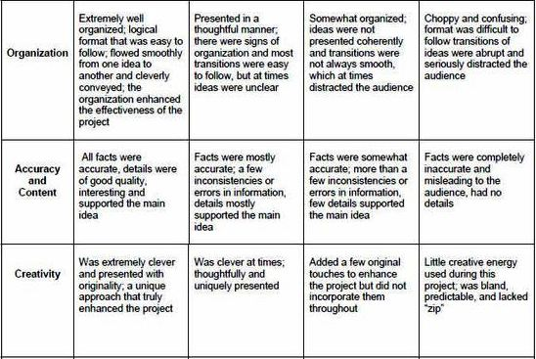

Criteria | Descriptors
Score | 5 points | 4 points | 3 points | 2 points | 1 point
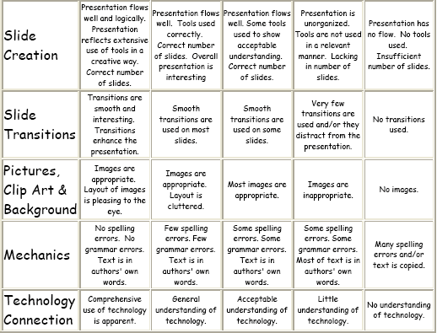

Criteria | Descriptors
Score | 4 points | 3 points | 2 points | 1 point
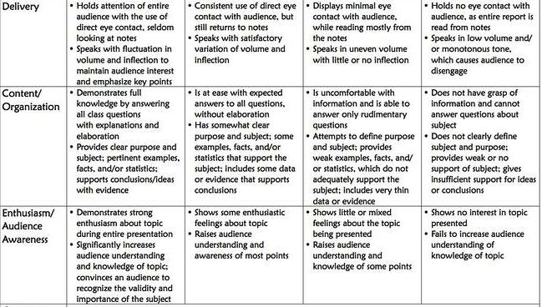

49 - 50p. – « 10» 15 –23p. - « 5»
46 – 48p. - « 9» 9 - 14p. - « 4»
39 – 45p. - « 8» 5 - 8p. - « 3»
34 – 38p. - « 7» 3 - 4p. - « 2»
24 – 33p. - « 6» 1 - 2p. - « 1»

