The 2nd level
Unit 4

COMPECENCE: Communicative Competence – Producing oral messages (Speaking)
UNITS OF COMPECENCES:
Producing a simple speech with appropriatef luency, stress, intonation.
Using an appropriate vocabulary, including the old and the new words.

OBJECTIVES:
- to speak briefly about their favourite season, using the apropriate vocabulary.
- to follow the given instructions/plan.

Evaluationtool:Thematic monologue
Topic: My favourite season
Task: Speak briefly about yourself in 5 sentences following the plan on the board:
- The favourite season (1 sentence);
- Reason (1 sentence);
- Months (1sentence);
- Season colour (1 sentence);
- Weather (1 sentence).

Evaluationcriteria:
- The Speech Content and Volume
- The Vocabulary Used
- Correctness in communication / usage the grammaer rules
- Pronunciation and Speech Fluency

Evaluation scale: Oral communication value rubric

ORAL COMMUNICATION VALUE RUBRIC
Evaluation  Criteria | Descriptors
 | Green | Yellow | Red
The Speech Content and Volume | The pupil speaks about all the aspects in order of their appearance in the plan, producing 8-10 complete simple sentences individualy, without teacher’s support. | The pupil speaks about almost all the aspects in order of their appearance in the plan, producing 6-10 complete simple sentences with a little support. | The pupil speaks about the most of the aspects in order of their appearance in the plan, producing 5-10 complete simple sentences with more support.
The Vocabulary Used | The pupil uses a rich, appropriate vocabulary, knows the old and the new words. | The pupil uses a rather rich vocabulary, appropriate to the topic, knows the old and the new words. | The pupil uses a varied vocabulary appropriate to the topic, knows the old and the new words.
Correctness in communication / usage the grammaer rules | Makes up correct sentences, without any grammar mistakes. | Makes 1-3 grammar mistakes. | Makes 1-6 grammar mistakes.
Pronunciation and Speech Fluency | The pupil speaks correctly, fluently and expressively articulating clearly and correctly, all the sounds, groups of sounds, in simple words and statements, without hesitation or pronunciation error, putting the emphasis correctly. | The pupil speaks fluently, expressively, producing almost all the sounds, sound groups, in simple words and sentences, with very little hesitation with 1-3 pronunciation error. | The pupil articulates in plain words and sentences, with little hesitations and 1-6 pronunciation and intonation errors that do not affect the understanding of the message.

FIŞĂ DE AUTOEVALUARE
Disciplina: Limba engleză
Clasa: III-a
Capacitatea evaluată: Monologul tematic (Alcătuirea propozițiilor, enunțurilor)
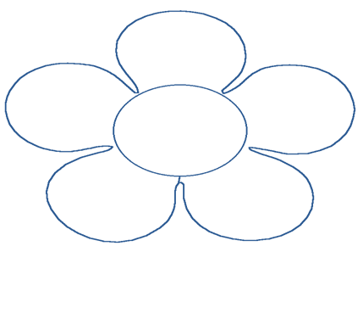
Numele, prenumele elevului (ei)_______________________ Data__________

Am rostit corect cuvintele
Am respectat tema și planul

Am vorbit fluent și corect gramatical
Am folosit vocabularul potrivit

Cheia evaluării:
V | Corect | G | Cu mici ezitări | R | Ghidat de învățător

FIŞĂ DE AUTOEVALUARE
Disciplina: Limba engleză
Clasa: III-a
Capacitatea evaluată: Monologul tematic (Alcătuirea propozițiilor, enunțurilor)
Numele, prenumele elevului (ei)_______________________ Data__________

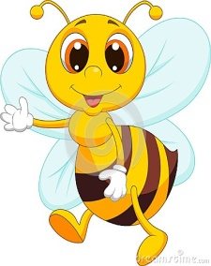
Am rostit corect cuvintele
Am respectat tema și planul

Am vorbit fluent și corect gramatical
Am folosit vocabularul potrivit

Cheia evaluării:
V | Corect | G | Cu mici ezitări | R | Ghidat de învățător

SELF-EVALUATION
Subject: English
Form: The 3rd
Evaluated Skill: Speaking - Thematic Monologue (Making up sentences)
Student’s name:_______________________ Date:__________

I pronounced the words correctly
I respected the topic and the plan

I spoke fluently and correctly

I used the appropriate vocabulary

Evaluation key:
G | Correct | Y | With little hesitation | R | Guided by the teacher

SELF-EVALUATION
Subject: English
Form: The 3rd
Evaluated Skill: Speaking - Thematic Monologue (Making up sentences)
Student’s name:_______________________ Date:__________

I pronounced the words correctly
I respected the topic and the plan

I spoke fluently and correctly

I used the appropriate vocabulary

Evaluation key:
G | Correct | Y | With little hesitation | R | Guided by the teacher

